PRESS RELEASE

THE 43RD ASEAN SUMMIT 2023 COMMUNICATIONS AND MEDIA TEAM

No.29/SP/TKM-ASEAN2023/ENG/9/2023

President Ensures ASEAN Summit Preparations Completed

Jakarta, 1 September 2023 – Indonesia is ready to host the 43rd ASEAN Summit 2023.
This was affirmed by Indonesian President Joko "Jokowi" Widodo while inspecting the preparations for the 43rd ASEAN Summit in person by visiting the three venues where Summit events will take place. These include Jakarta Convention Center (JCC), GBK City Forest, and Plataran Greenhouse.
Information on the President’s visit was received by the Communications and Media Team of the 43rd ASEAN Summit on Friday (1 September 2023) in an official note which stated that the Head of State took the opportunity to sample the VVIP guest banquet.
President Jokowi's direct involvement in these preparations demonstrates the government's commitment to ensuring the success of the major Southeast Asian event, which is anticipated to provide future benefits to the ASEAN region.
"The preparations have reached 99 percent completion, it’s ready," said President Jokowi at the Media Center of the 43rd ASEAN Summit at the Jakarta Convention Center (JCC) on Friday (1 September 2023).
The Ministry of Public Works and Public Housing (PUPR) carried out the rehabilitation of the Jakarta Convention Center (JCC), GBK City Forest, and Plataran Greenhouse with excellence.
The JCC rehabilitation covered four zones: Zone 1 (lower ground), which includes the architectural work for the Kasuari Lounge, Merak Room, Nuri Room, Maleo Room, Kenari Room, Kakatua Room, Lower Lobby Pre Function, Summit Room, Summit Lounge, walkway to Hotel Sultan, prayer room, and restrooms;
Zone 2 (ground floor) includes architectural work for the Assembly Hall, Main Lobby, Cendrawasih Hall and Corridor, Pre Function Hall A, as well as the VIP Room and restrooms (Cendrawasih). Zone 3 (ground) includes the renovation of the Plenary Hall, corridors, and president's area.
Zone 4 (ground) includes the installation of canopies, the arrangement of drop-offs, front gardens, side gardens, restrooms, and outdoor prayer rooms.
Meanwhile, the Ministry of PUPR also increased the connectivity between GBK City Forest area and Plataran Greenhouse which are strategically located near each other by a preservation work on the 4.67 km road inside the Gelora Bung Karno area. Prior to the 43rd ASEAN Summit, the grass field within the GBK City Forest and Plataran Greenhouse is watered on a regular basis in order to maintain its green color.
The 43rd ASEAN Summit 2023 will be held at the Jakarta Convention Center on 5—7 September 2023, with the participation of 22 countries, including 11 ASEAN members: Indonesia, Malaysia, Singapore, Thailand, the Philippines, Brunei Darussalam, Viet Nam, Laos, Myanmar, Cambodia, and Timor-Leste.
In addition, there are nine invited partner countries, namely the Republic of Korea, India, Japan, China, New Zealand, Canada, Australia, Russia, and the United States. Two more countries to attend include Bangladesh as Chair of the Indian Ocean Rim Association (IORA) and Cooks Island as Chair of the Pacific Island Forum (PIF).
In addition, Indonesia is inviting the United Nations (UN), the World Bank, the International Monetary Fund (IMF), the World Economic Forum, IORA, and the PIF. (Toro/Dona/TR/PR)

***

For more information, please contact:

Director General of Public Information and Communications of the Ministry of Communications and Informatics – Usman Kansong (0816785320).

Find more information at http://asean2023.id, https://infopublik.id/kategori/asean-2023, and https://indonesia.go.id/kategori/ragam-asean-2023

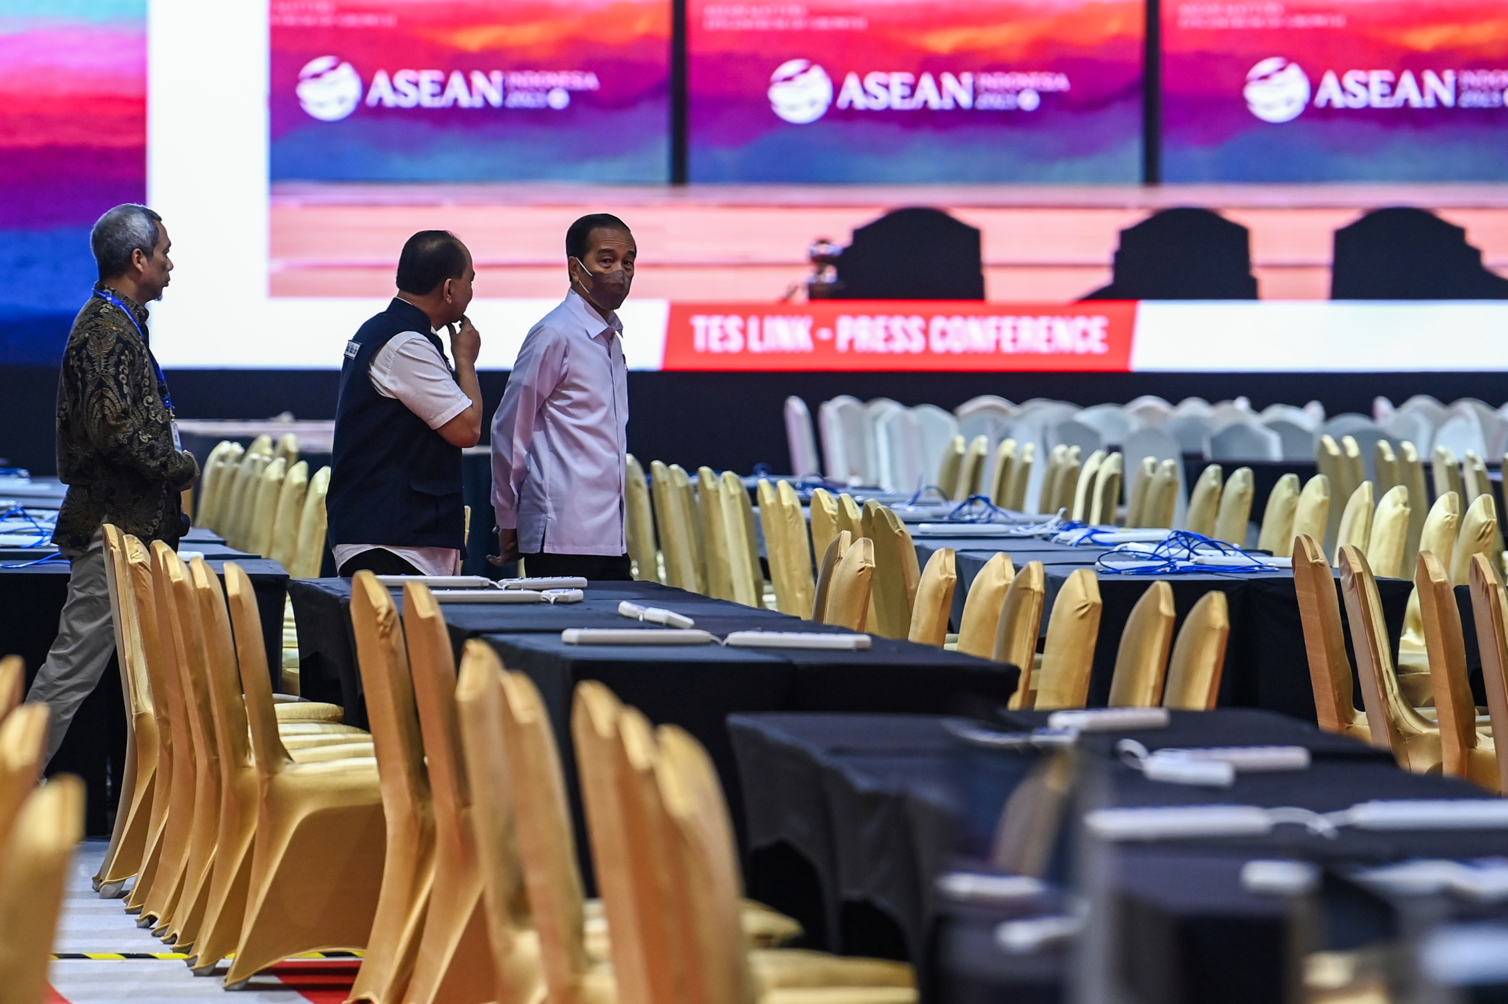

President Joko Widodo (right) accompanied by Minister of Communications and Informatics Budi Arie Setiadi (center) and MCI’s Director General of Public Information and Communication Usman Kansong (left) inspecting the media center of the 43rd ASEAN Summit 2023 at the Jakarta Convention Center, Jakarta, Friday (1 September 2023). ANTARA FOTO/MEDIA CENTER KTT ASEAN 2023/M Agung Rajasa/pras.

